

Lab -11 Introduction to AMazon Ec-2

Lab Support Guide for CATOR-28



October 27, 2022

CATOR 28

# Introduction

This Lab Support Guide is prepared to help participants of AWS Restart to complete the AWS Restart Lab Activity without any difficulty.

# Step -1

Click on Start Labs in the Voccareum Labs Page which is interlinked to AWS Restart Lesson -11 (11-[CF]-Lab -Introduction to Amazon EC-2.



# Step -2

Wait for the AWS Icon in the Left to turn Green.



# Step -3

Click on Details to Know the AWS Status of the Time allotted to complete the labs

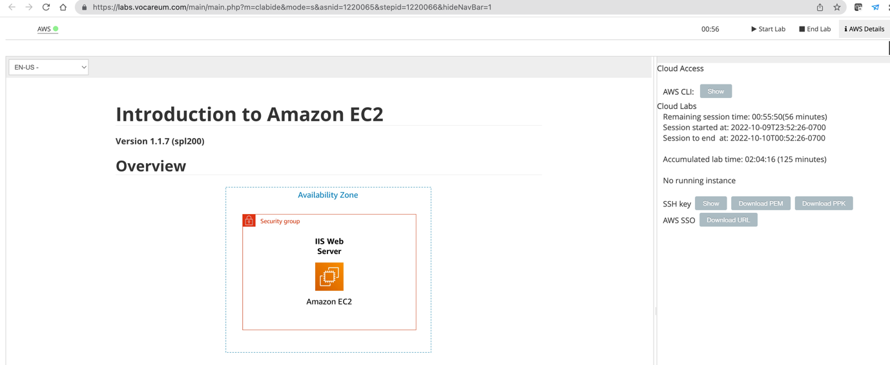

# Step -4

Click on the AWS Icon on the left end of the Page

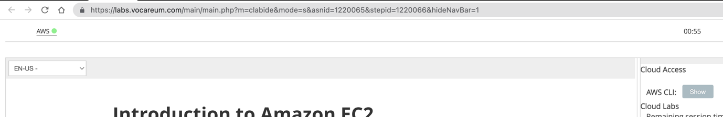

The AWS Console opens up displaying the **AWS Management Console** Page

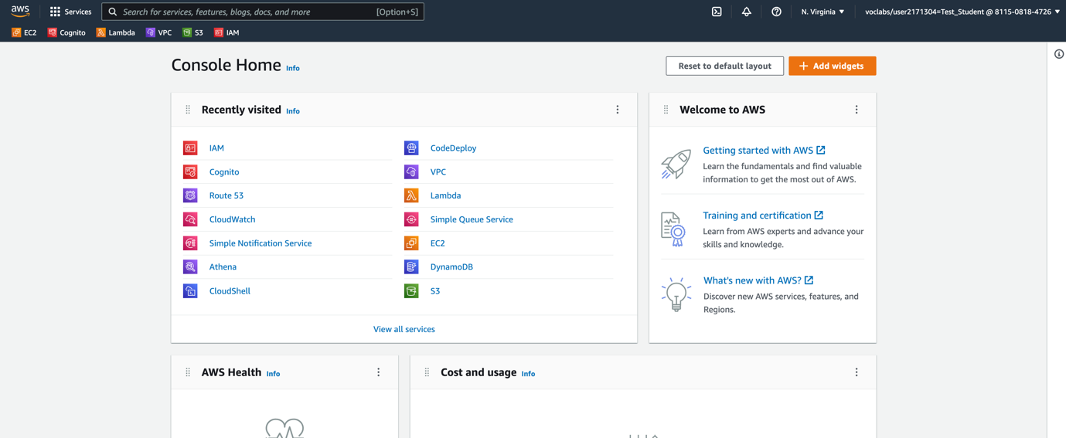

Note that you have been autosigned into Amazon Web Services which has a **service control policy** permitting you only to do the lab activity.

# Step -5

Click on EC2 which is present in the AWS Management Console or Pinned on Top.

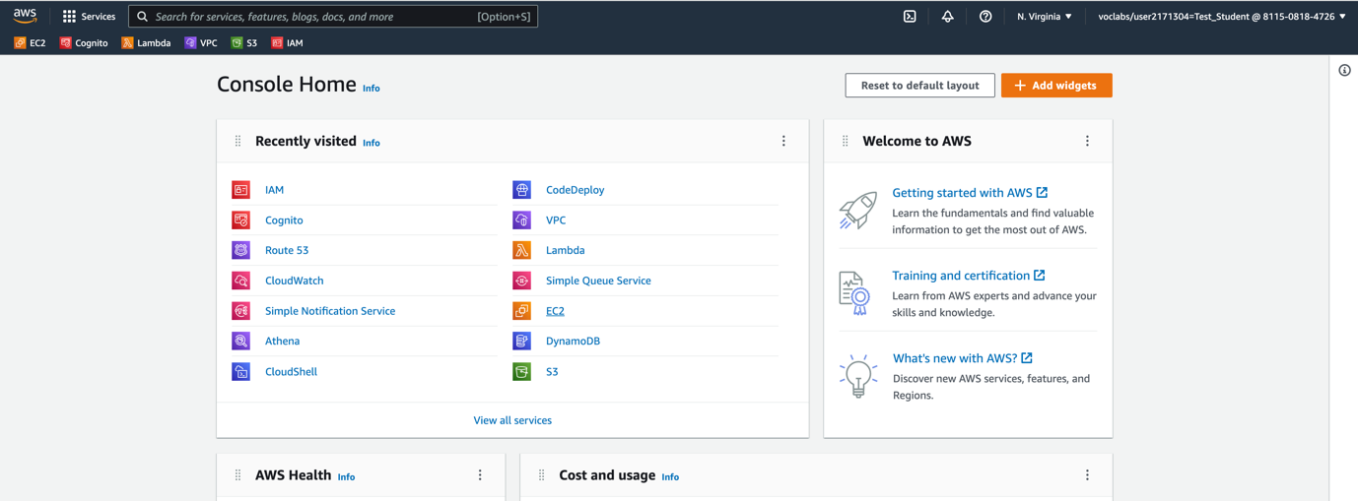

# Step -6

The EC-2 Dashboard Opens up displaying the Elastic Compute Cloud Environments which is to be used for the Lab Activity.

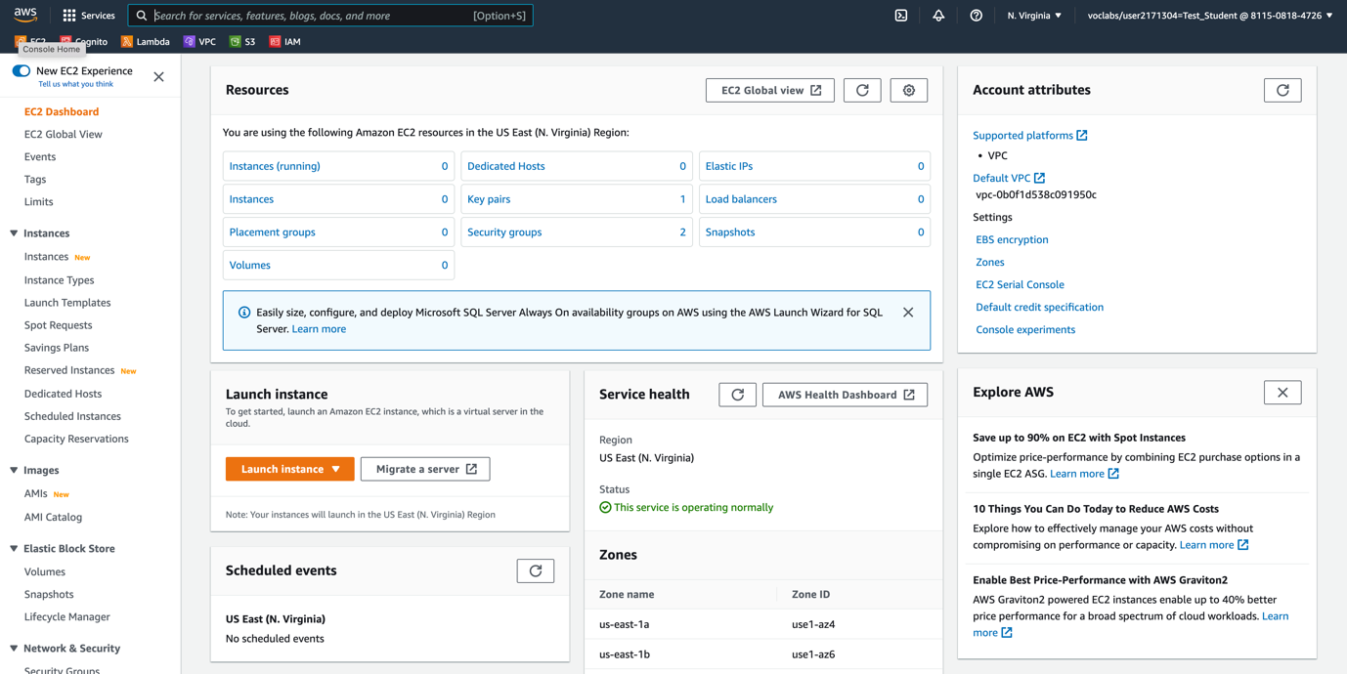

# Step -7

Click on Launch Instance to Launch the EC-2 Instances

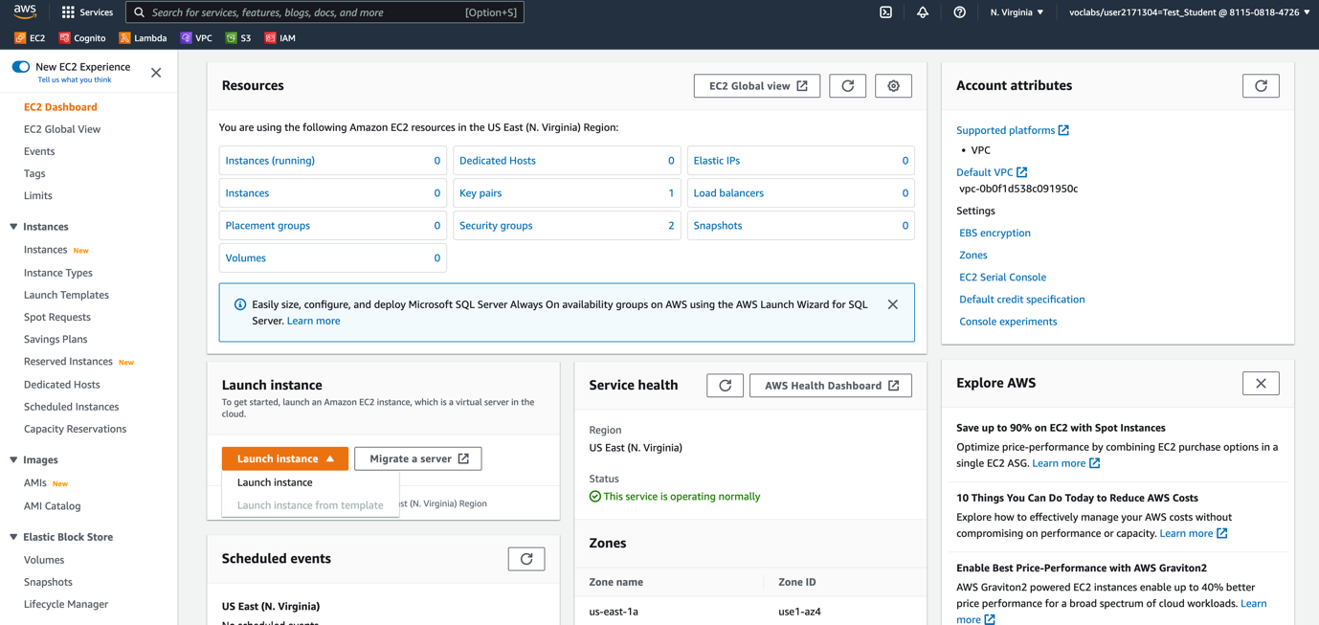

# Step -8

In the **Name and tags** pane, in the **Name** text box, enter Web Server

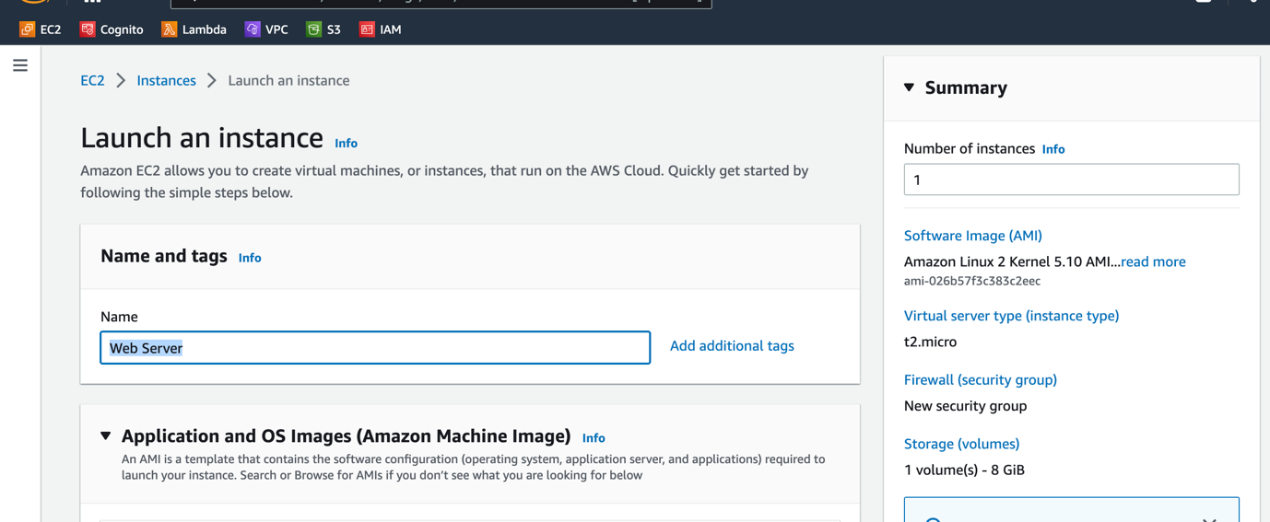

# Step -9

Choose an Amazon Machine Image **Amazon Linux 2 AMI. Normally this gets selected as default.**

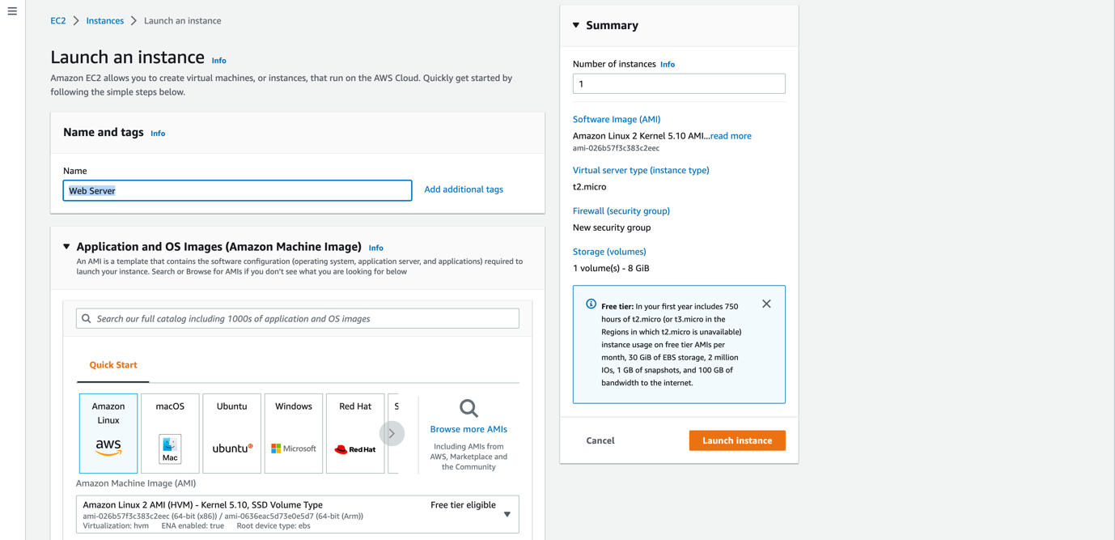

# Step -10

Choose an Instance Type. Select T-3 Micro

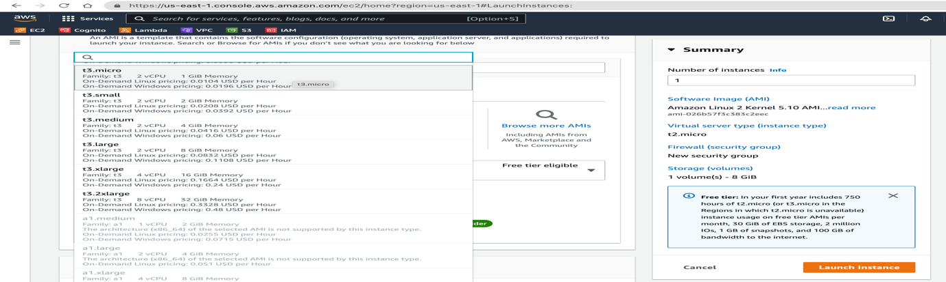

# Step -11

In the Keypair login *(required) select Proceed without a Keypair (Not Recommended)*

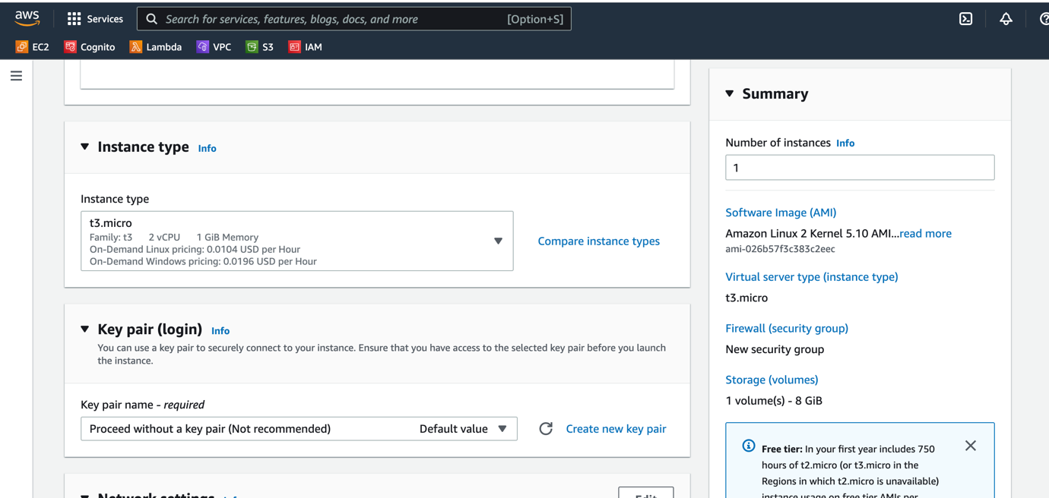

# Step -12 Configure the Network Settings

The VPC is your own isolated Network on the AWS Cloud .While creation of a AWS Environment there is a default VPC that is created.

In the **Network settings** pane, choose **Edit**

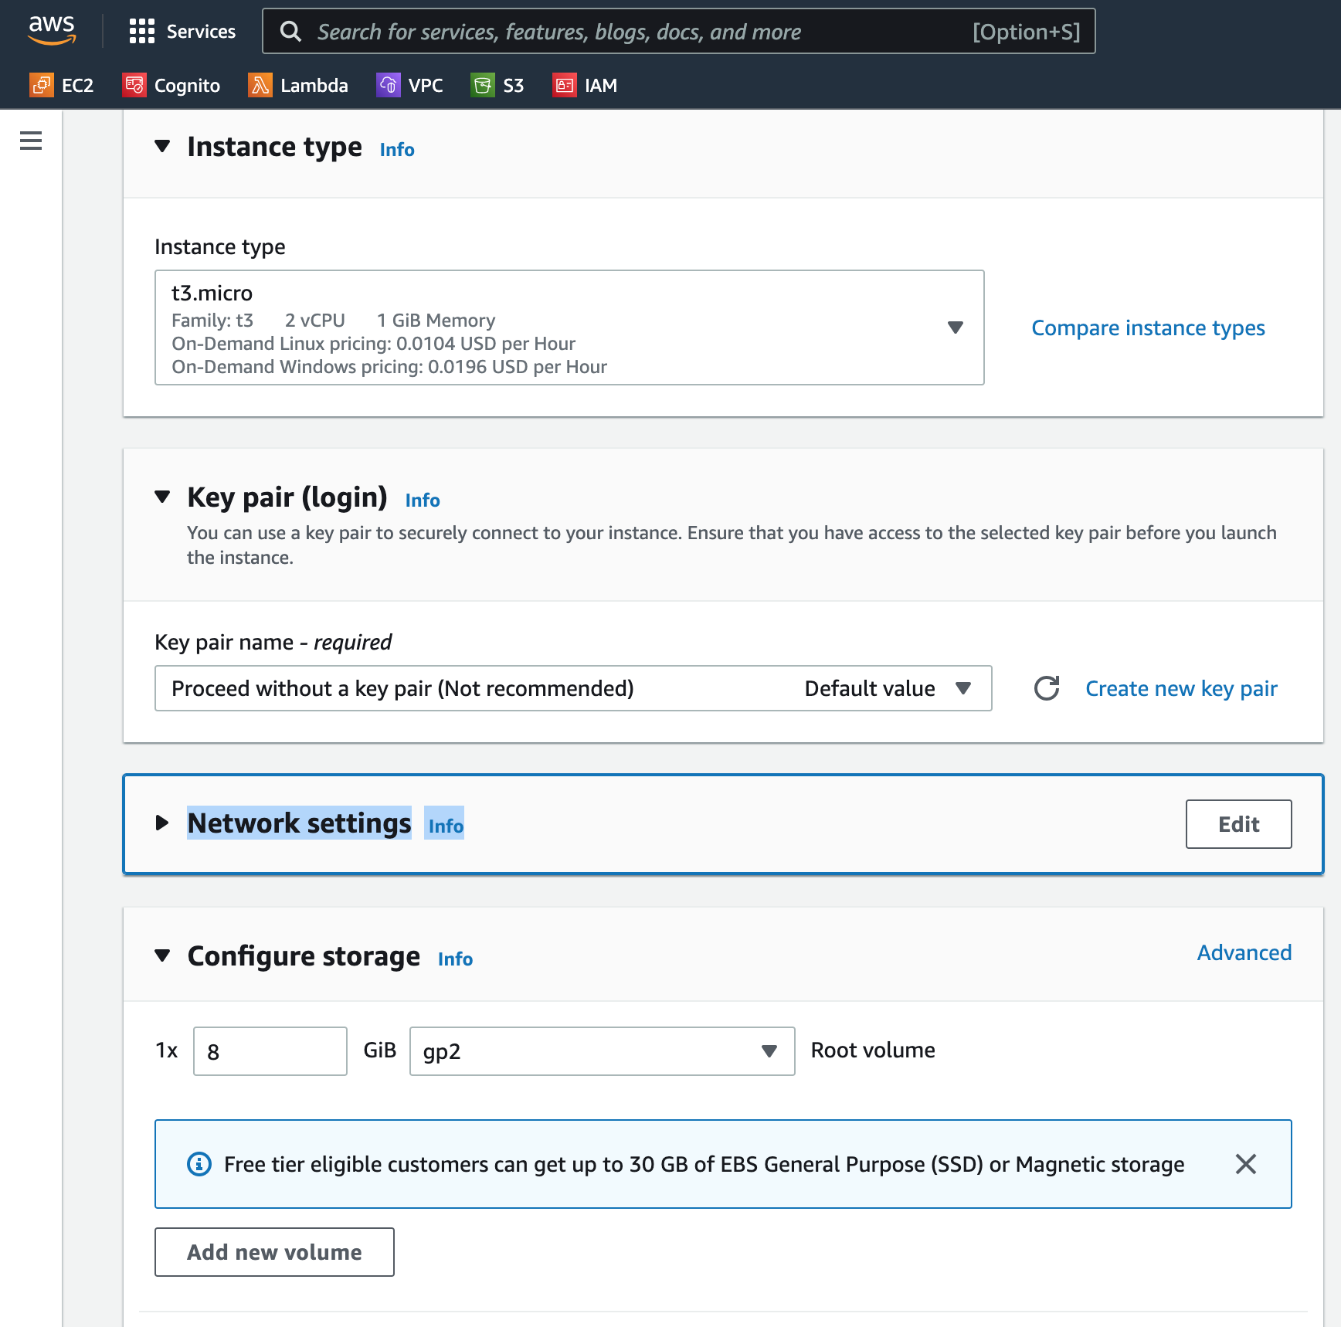

For **VPC - *required***, select **Lab VPC**.

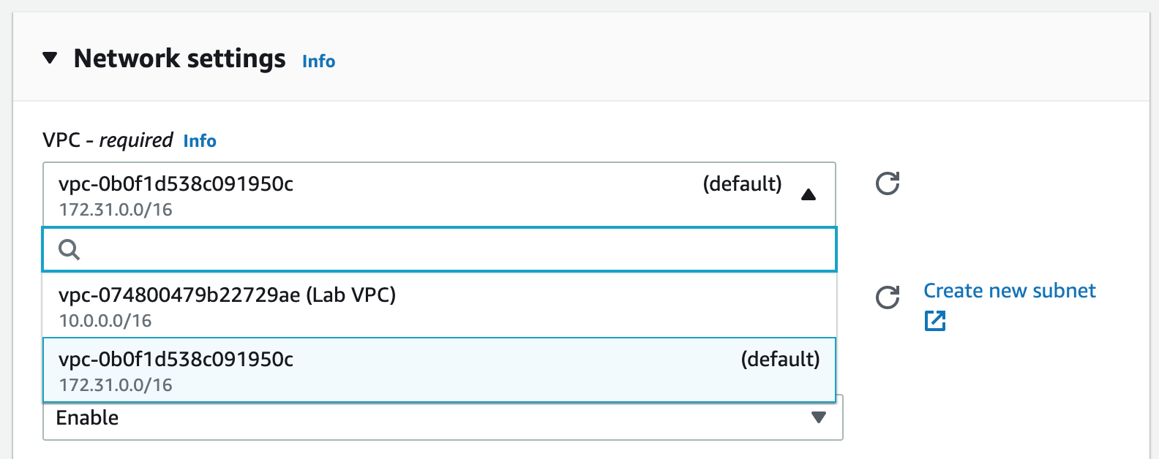

Note that the IP has a structure ***.**.**.* /16 which gives plenty of addresses

Still in the **Network settings** pane, configure the Security Group as follows:

|  |  |
| --- | --- |
| Security Group | Web Server Security Group |
| Description | Security group for my web server |

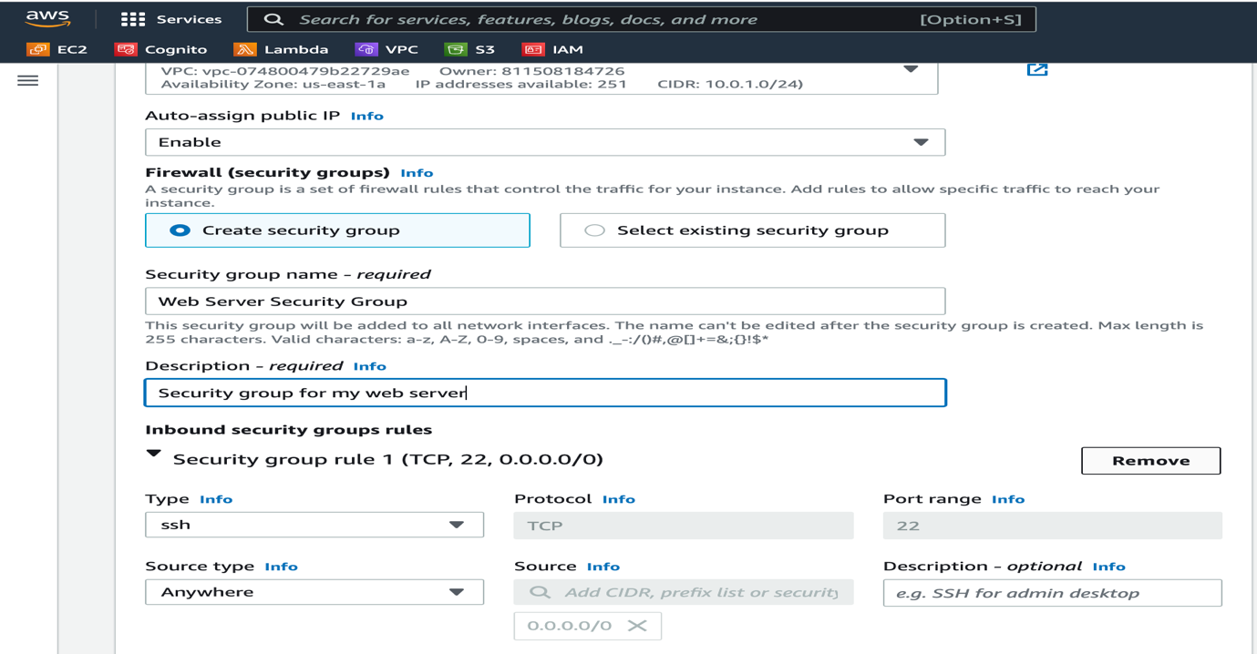

Click on Remove and Remove the Inbound Security Group

# Step -6

Add Storage

Amazon EC2 stores data on a network-attached virtual disk called Amazon Elastic Block Store (Amazon EBS).

You launch the EC2 instance using a default 8 GiB disk volume. This is your root volume (also known as a boot volume).

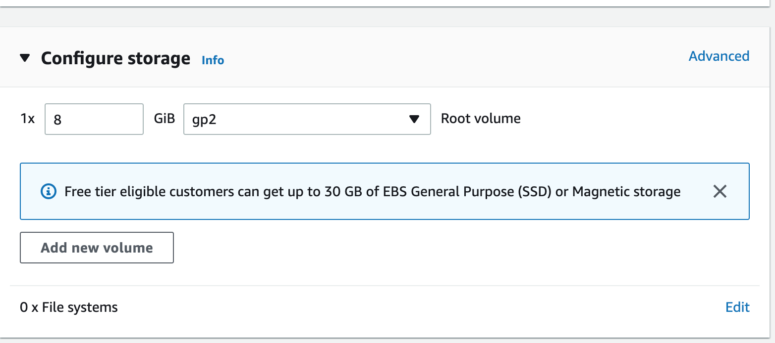

# Step -7

Configure Advanced Details

Expand the **Advanced details** pane.

Select the dropdown for **Termination protection**, then choose **Enable**.By doing this step you are protecting the EC-2 Instance from accidental termination.

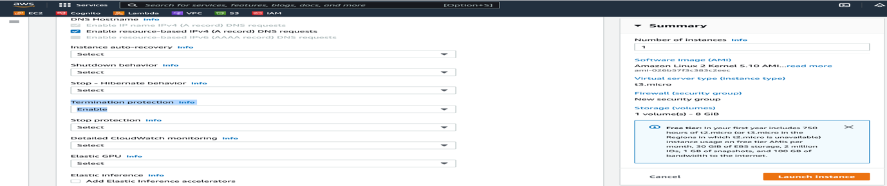

When you launch an instance in Amazon EC2, you have the option of passing user data to the instance. These commands can be used to perform common automated configuration tasks and even run scripts after the instance starts.

Copy the following commands, and paste them into the **User data** text box.We do this to install Apache Web Server.The Last line with the prefix echo is the message seen in the welcome page .

#!/bin/bash

yum -y install httpd

systemctl enable httpd

systemctl start httpd

echo '<html><h1>Hello From Your Web Server!</h1></html>' > /var/www/html/index.html

# Step -8 .

Click on Launch Instance

Note that the Launch activity takes you back to the EC-2 Dashboard which shows the instances starting up

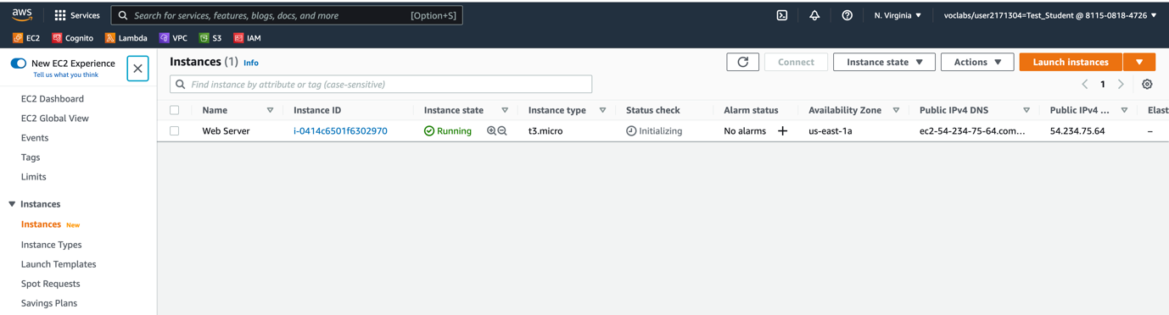

# Step -9

Copy the Public IP

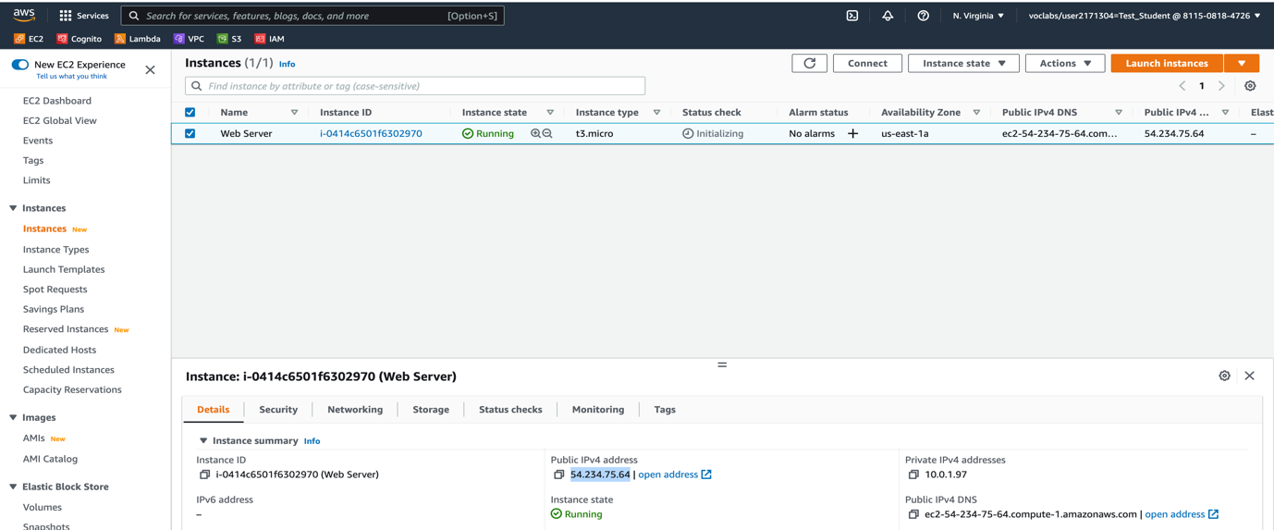

# Step -10

Try opening the Address in a new Window

There is no response

# Step -11

Edit Existing Security Group to allow inbound rules to permit traffic on Port 80.This should allow HTTP Requests to reach our EC-2 Instance

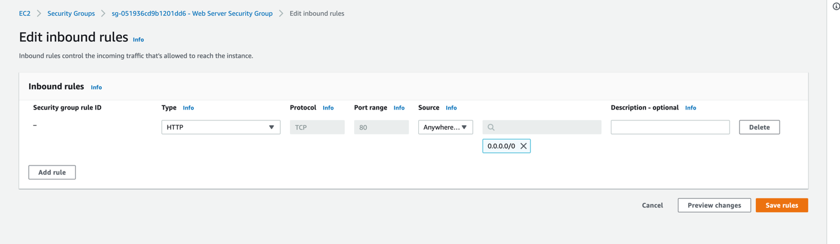

Save the Rule

# Step -12

Reopen the Webpage with the Public IP .Remove the Secure part (https) and use only http.

The Webpage opens up showing the message **“Hello From Your Web Server!”**

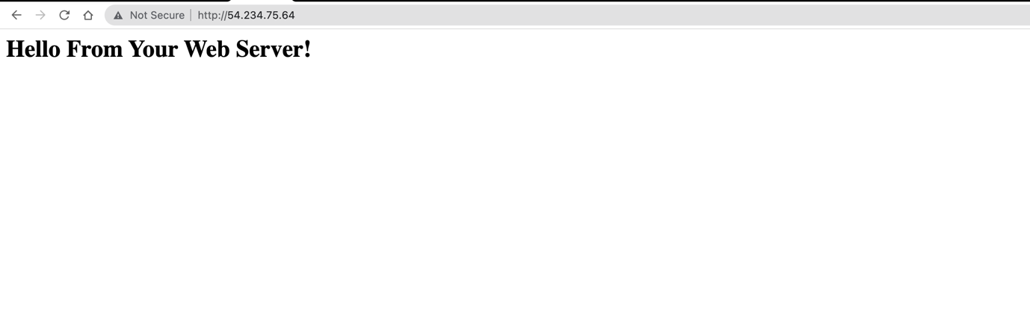

End of Labs